## **SUPPLEMENTARY MATERIAL**

**Additional explanation of intervention scenarios**

|  |  |  |  |
| --- | --- | --- | --- |
| Scenario | | *β(t)* during the simulation | Real-world Parallels |
| 1 |  | | A classic interpretation of NPIs such as lockdown measures, a flat constant reduction to transmission which is sustained until the cessation of the intervention. Used in a variety of models considering the effects of NPIs (1-4). |
| 2 |  | | “Ramping down” strategy, an initial strong intervention is followed by a gradual reduction in the strength of the intervention. Can draw parallels to the gradual re-opening strategies adopted by countries after having instituted strong NPIs. The purpose of this strategy is to slowly reinvigorate the economy and allow greater levels of population movement following a restrictive NPI (3, 5, 6). |
| 3 |  | | A “ramping up” strategy, uses a slow deliberate introduction of harsher NPI measures over time, with the intervention reaching its greatest magnitude as the intervention is finishing. After this point, NPI restrictions are lifted. Due to the riskier nature of this intervention scenario, evidence of this intervention scenario is not common in epidemiological or modelling literature. However we envisage a scenario where policy makers attempt to reactively increase the strength of interventions over time to mitigate potential economic effects of NPI measures, as opposed to an instantaneous population lockdown in response to new cases . |
| 4 |  | | A hybrid of scenario 2 and 3, involving a ramping up and ramping down of intervention measures. Real-world parallels to this strategy are rare, but could involve a scenario where a policy-maker ramps up outbreak response and deems the situation controlled enough to initiate a controlled ramping down of measures after the peak of the outbreak has passed. |
| 5 |  | | The pulsed intervention scenario has parallels with hypothetical interventions aiming to control COVID-19. Two types of pulsed measures have been theorised, either a “triggered” pulse measure in response to epidemiological threshold being met (ICU bed capacity or incidence), or an “open loop” pulse which uses fixed timings, independent of the epidemiological situation, to introduce the intervention (4, 5, 7-9). |

**Table S1 – Parameters for the single intervention scenario**

|  |  |  |  |  |
| --- | --- | --- | --- | --- |
| **Parameter Description** | | **Notation** | **Baseline Value** | **References** |
| Doubling Time | | *td* | 3 Days | (10, 11) |
| Baseline Basic Reproduction Number | | *R0* | 2.8 (baseline) - used to calculate gamma | (9, 12-14) |
| Generation Time | | *G* | 7.8 days | Calculated from eqn 1.2 (15) |
| Per capita rate of recovery from COVID-19 infection | | *γ* | 0.128 | Calculated from *1/G* |
| Per capita rate of COVID-19 transmission (Baseline) | | *β* | 0.359 | Calculated from *R0γ* |
| Scaled per capita rate of COVID-19 transmission (reflects the impact of small-scale NPIs on transmission) | | *βscale* | 0.2513 (30% reduction to baseline *β*) | (9, 14, 16) |
| Minimum value of the lockdown-related scaling factor *c(t)* | | *cmin* | 0.4 (60% reduction to *βscale*) | (9, 14, 16) |
| Length of Intervention | Scenario 1 | *dt* | 84 days (12 weeks) | N/A |
| Scenario 2, 3, 4 and 5 | 168 days (24 weeks) | N/A |
| Intervention Trigger Point | | *tp* | Day 52 (*Ic(52)* = 0.02) | Calculated from Model |

**Table S2 – Parameters for the multi intervention scenario**

|  |  |  |  |  |
| --- | --- | --- | --- | --- |
| **Parameter Description** | | **Notation** | **Baseline Value** | **References** |
| Doubling Time | | *Td* | 3 Days | (10, 11) |
| Baseline Basic Reproduction Number | | *R0* | 2.8 (baseline) - used to calculate gamma | (9, 12-14) |
| Generation Time | | *G* | 7.8 days | Calculated from eqn 1.2 (15) |
| Per capita rate of recovery from COVID-19 infection | | *γ* | 0.128 | Calculated from *1/G* |
| Per capita rate of COVID-19 transmission (Baseline) | | *β* | 0.359 | Calculated from *R0γ* |
| Scaled per capita rate of COVID-19 transmission (reflects the impact of small-scale NPIs on transmission) | | *βscale* | 0.2513 (30% reduction to baseline *β*) | (9, 14, 16) |
| Minimum value of the lockdown-related scaling factor *c(t)* – Intervention 1 | | *cmin1* | 0.4 (60% reduction to *βscale*) | (9, 14, 16) |
| Minimum value of the lockdown-related scaling factor *c(t)*– Intervention 2 | | *cmin2* | 0.4 (60% reduction to *βscale*) | (9, 14, 16) |
| Length of Intervention – Intervention 1 | Scenario 1 | *dt1* | 42 days (6 weeks) | N/A |
| Scenario 2, 3, 4 and 5 | 84 days (12 weeks) | N/A |
| Length of Intervention – Intervention 2 | Scenario 1 | *dt2* | 42 days (6 weeks) | N/A |
| Scenario 2, 3, 4 and 5 | 84 days (12 weeks) | N/A |
| Intervention Trigger Point – Intervention 1 | | *tp1* | Day 52 (*Ic(52)* = 0.02) | Calculated from Model |
| Intervention Trigger Point – Intervention 2 | | *tp2* | Day 52 (*Ic(52)* = 0.02) | Calculated from Model |

**Software and R Packages Used**

R packages used to run model ODEs, plotting and data manipulation are as follows: “desolve” ((17)), “ggplot2” (18) and “reshape2” (19).

**Table S3 – Optimal parameter values for the main text model sensitivity analyses**

|  |  |  |  |  |  |  |  |
| --- | --- | --- | --- | --- | --- | --- | --- |
| **Sensitivity Analysis** | **Scenario** | **Value of the optimised outcome measure** | | **Optimal Value of Parameter 1** | | **Optimal Value of Parameter 2** | |
| ***Imax*** | ***Ic(tmax)*** | ***Imax*** | ***Ic(tmax)*** | ***Imax*** | ***Ic(tmax)*** |
| **Single-intervention**  **(*tp*)**  **(Figure 1B)** | **1** | 0.055 | 0.503 | 72 | 86 |  | |
| **2** | 0.035 | 0.504 | 67 | 85 |
| **3** | 0.035 | 0.517 | 7 | 24 |
| **4** | 0.037 | 0.508 | 38 | 53 |
| **5** | 0.059 | 0.516 | 32/53/74 | 79 |
| **Single-intervention**  **(*cmin*)**  **(Figure 1B)** | **1** | 0.051 | 0.067 | 0.72 | 0.77 |
| **2** | 0.055 | 0.648 | 0.56 | 0.62 |
| **3** | 0.087 | 0.545 | 0.00 | 0.00 |
| **4** | 0.044 | 0.671 | 0.00 | 0.41 |
| **5** | 0.052 | 0.573 | 0.27 | 0.47 |
| **Single-intervention**  **(*dt*)**  **(Figure 1B)** | **1\*** | 0.131 | 0.774 | 328 | N/A |
| **2** | 0.041 | 0.601 | 400 | 400 |
| **3** | 0.054 | 0.565 | 60 | 97 |
| **4** | 0.044 | 0.506 | 100 | 174 |
| **5** | 0.058 | 0.500 | 104/175 | 270 |
| **Single-intervention**  **(*tp*/*dt*)**  **(Figure 2)** | **1\*** | 0.065 | 0.426 | 70 | 80 | 250 | 250 |
| **2** | 0.031 | 0.415 | 66 | 80 | 250 | 250 |
| **3** | 0.033 | 0.471 | 0 | 0 | 184 | 221 |
| **4** | 0.033 | 0.432 | 22 | 31 | 248 | 250 |
| **5** | 0.057 | 0.474 | 42 | 79 | 244 | 250 |
| **Multi-intervention**  **(*tp1*/*tp2*)**  **(Figure 3A)** | **1** | 0.038 | 0.505 | 68 | 86 | 22 | 9 |
| **2** | 0.046 | 0.512 | 39 | 80 | 0 | 0 |
| **3** | 0.037 | 0.515 | 38 | 50 | 0 | 0 |
| **4** | 0.041 | 0.511 | 54 | 65 | 0 | 0 |
| **5** | 0.054 | 0.521 | 34 | 70 | 0 | 0 |
| **Multi-intervention**  **(*cmin1*/*cmin2*)**  **(Figure 3B)** | **1** | 0.049 | 0.514 | 0.26 | 0.52 | 0.62 | 0.00 |
| **2** | 0.095 | 0.515 | 0.64 | 0.01 | 0.00 | 0.00 |
| **3** | 0.044 | 0.495 | 0.00 | 0.23 | 0.00 | 0.00 |
| **4** | 0.048 | 0.546 | 0.54 | 0.00 | 0.00 | 0.00 |
| **5** | 0.070 | 0.515 | 0.49 | 0.01 | 0.00 | 0.00 |

*Note that scenario 1 *dt* sensitivity analyses were used a transformed relative scale for *dt* to allow for comparison across scenarios, with the relative scale of 0 ≤ *dt* ≤ 400 being equal to an absolute *dt* range of 0 ≤ *dt* ≤ 200.

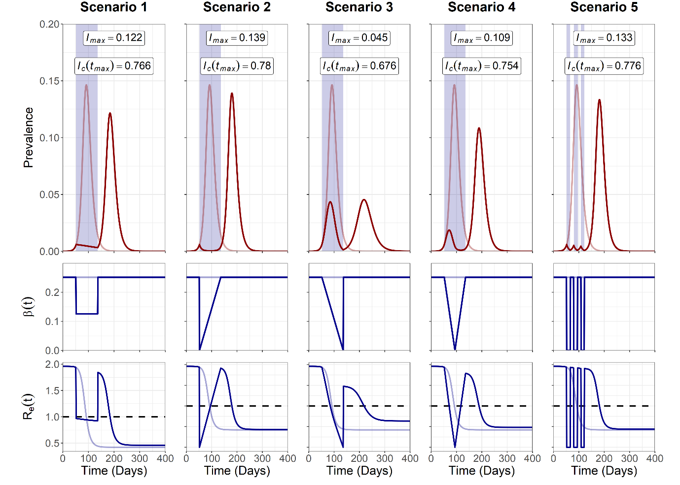

**Figure S1. Trajectory plots for the single intervention epidemic curve, *β(t)* reductions and *Re(t)* for the alternative methodology to double *cmin* to ensure similar magnitude of intervention across the intervention durations for scenario 2, 3, 4 and 5.** Note that for A) opaque red and blue lines in the trajectory plot depict unmitigated epidemic curve dynamics. Blue shading indicates the period of the intervention. Dotted line on the *Re(t)* plot denotes the threshold for sustained epidemic growth. *Imax* and *Ic(tmax)* values are annotated for each scenario. Scenario 1 was set at *cmin* = 0.5 to allow for scenario 2, 3, 4 and 5 to be set at *cmin* = 0 (double the intervention magnitude).

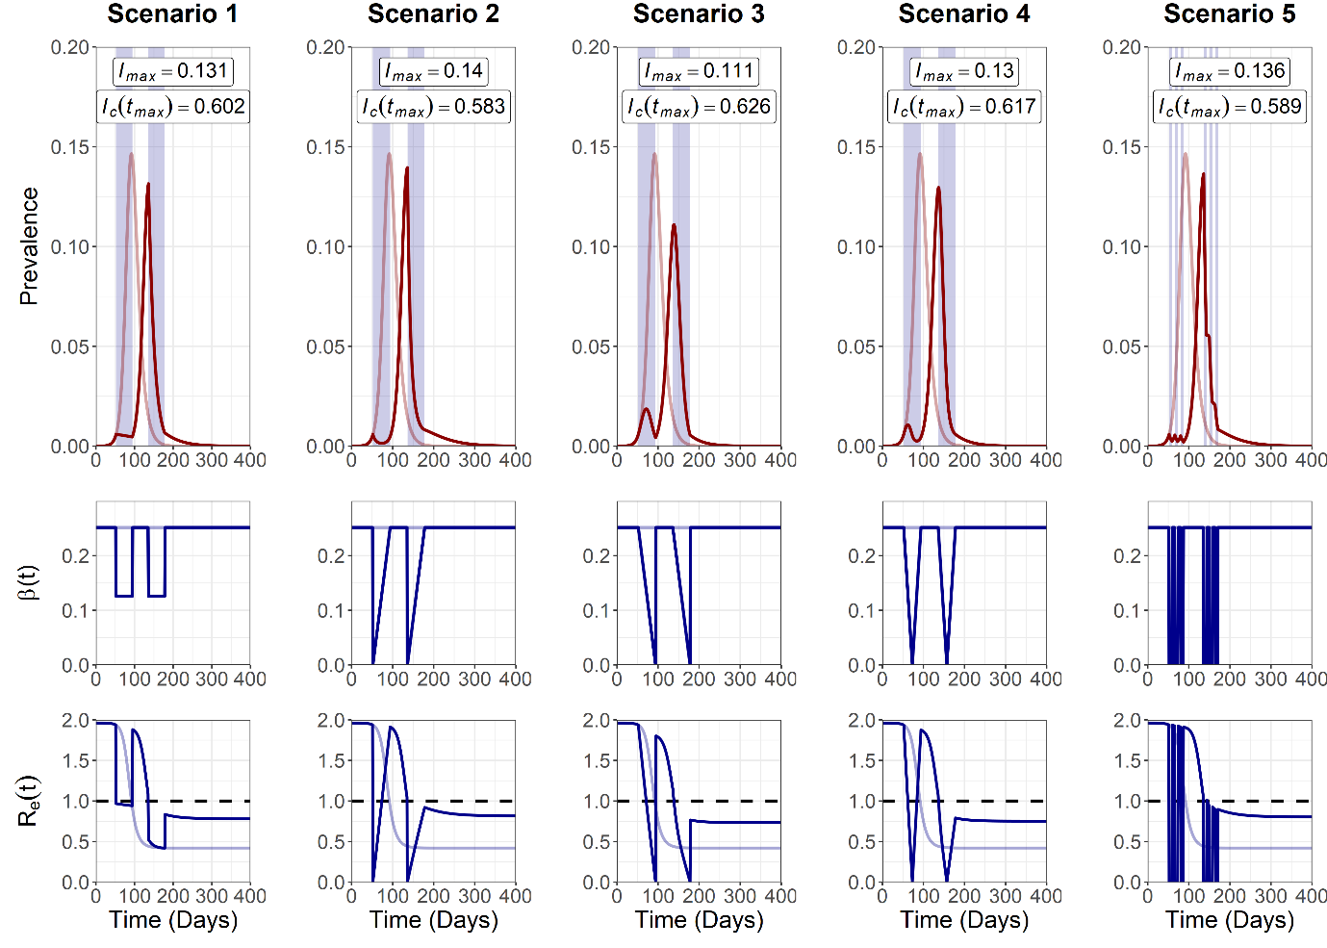

**Figure S2. Trajectory plots for the multiple intervention epidemic curve, *β(t)* reductions and *Re(t)* for the alternative methodology to double *cmin* to ensure similar magnitude of intervention across the intervention durations for scenario 2, 3, 4 and 5.** Note that for A) opaque red and blue lines in the trajectory plot depict unmitigated epidemic curve dynamics. Blue shading indicates the period of the intervention. Dotted line on the *Re(t)* plot denotes the threshold for sustained epidemic growth. *Imax* and *Ic(tmax)* values are annotated for each scenario. Scenario 1 was set at *cmin* = 0.5 to allow for scenario 2, 3, 4 and 5 to be set at *cmin* = 0 (double the intervention magnitude).

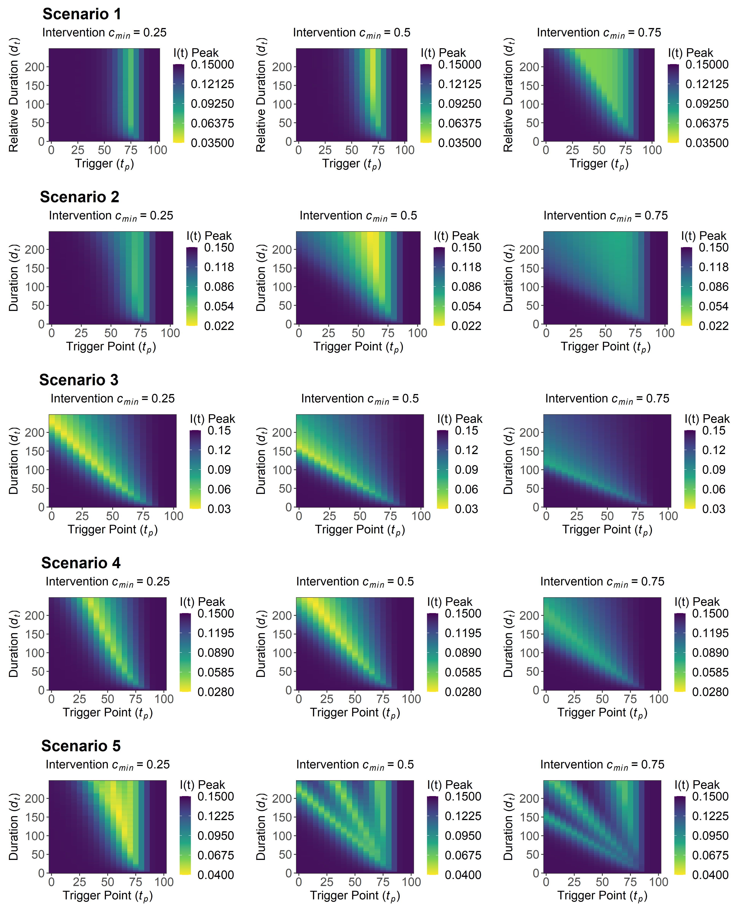

**Figure S3. Sensitivity analysis for maximum *I(t)* peak, *Imax* for intervention trigger day, *tp*, and the intervention duration, *dt*, explored for varying values of *cmin*.** Note that the scenario 1 *dt* axis was transformed into a relative axis to allow for comparison across scenarios, with the relative axis of 0 ≤ *dt* ≤ 250 being equal to an absolute *dt* range of 0 ≤ *dt* ≤ 125.

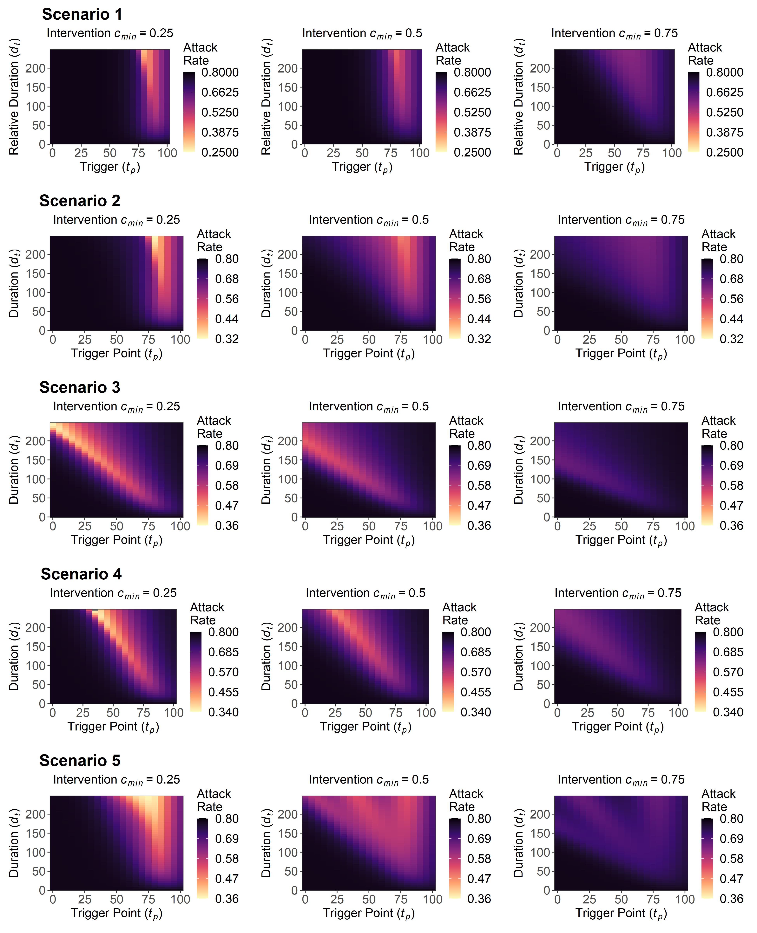

**Figure S4. Sensitivity analysis for the attack rate, *Ic(tmax)* for intervention trigger day, *tp*, and the intervention duration, *dt*, explored for varying values of *cmin*.** Note that the scenario 1 *dt* axis was transformed into a relative axis to allow for comparison across scenarios, with the relative axis of 0 ≤ *dt* ≤ 250 being equal to an absolute *dt* range of 0 ≤ *dt* ≤ 125.

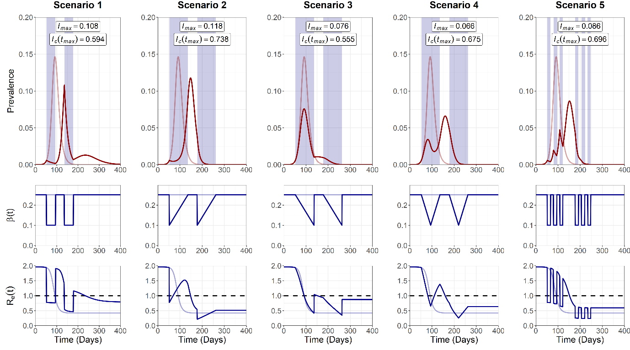

**Figure S5. Trajectory plots for the epidemic curve, intervention associated *β(t)* reductions and Re*(t)*, for the five multi-intervention scenarios.** Opaque red and blue lines depict unmitigated epidemic curve dynamics.Blue shading on the trajectory plot indicates the period of the intervention. Dotted line denotes the *Re(t)* threshold for sustained epidemic growth.*Imax* and *Ic(tmax)* values are annotated for each scenario.

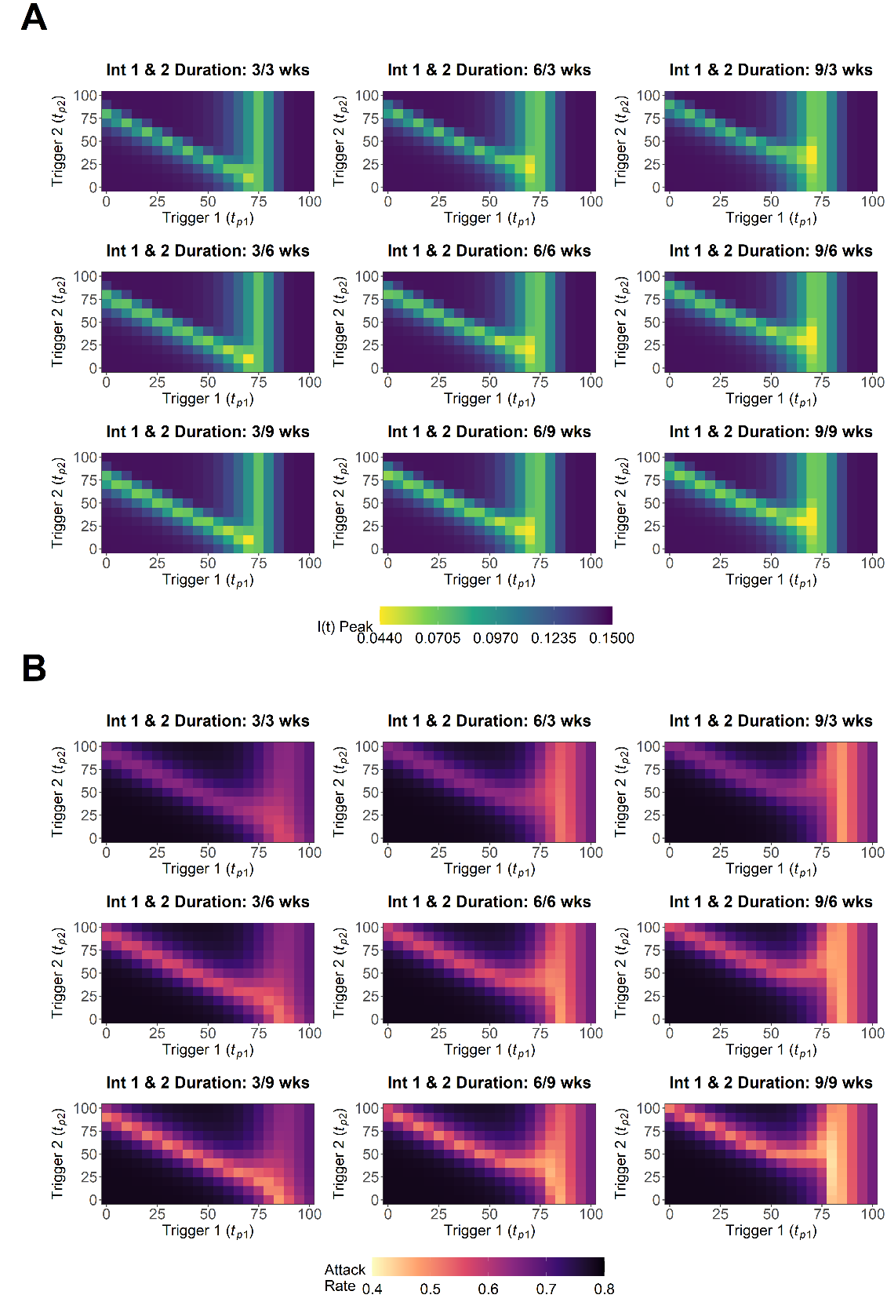

**Figure S6. Scenario 1 sensitivity analysis for A) maximum I(t) peak, *Imax*, and B) attack rate, *Ic(tmax)*, for intervention 1 trigger date, *tp1*, and intervention 2 trigger date, *tp2*, explored for varying combinations of the duration of intervention 1, *dt1*, and intervention 2, *dt2*.** Combinations of *dt1* = *dt2* = 3/6/9 weeks were explored in this sensitivity analysis.

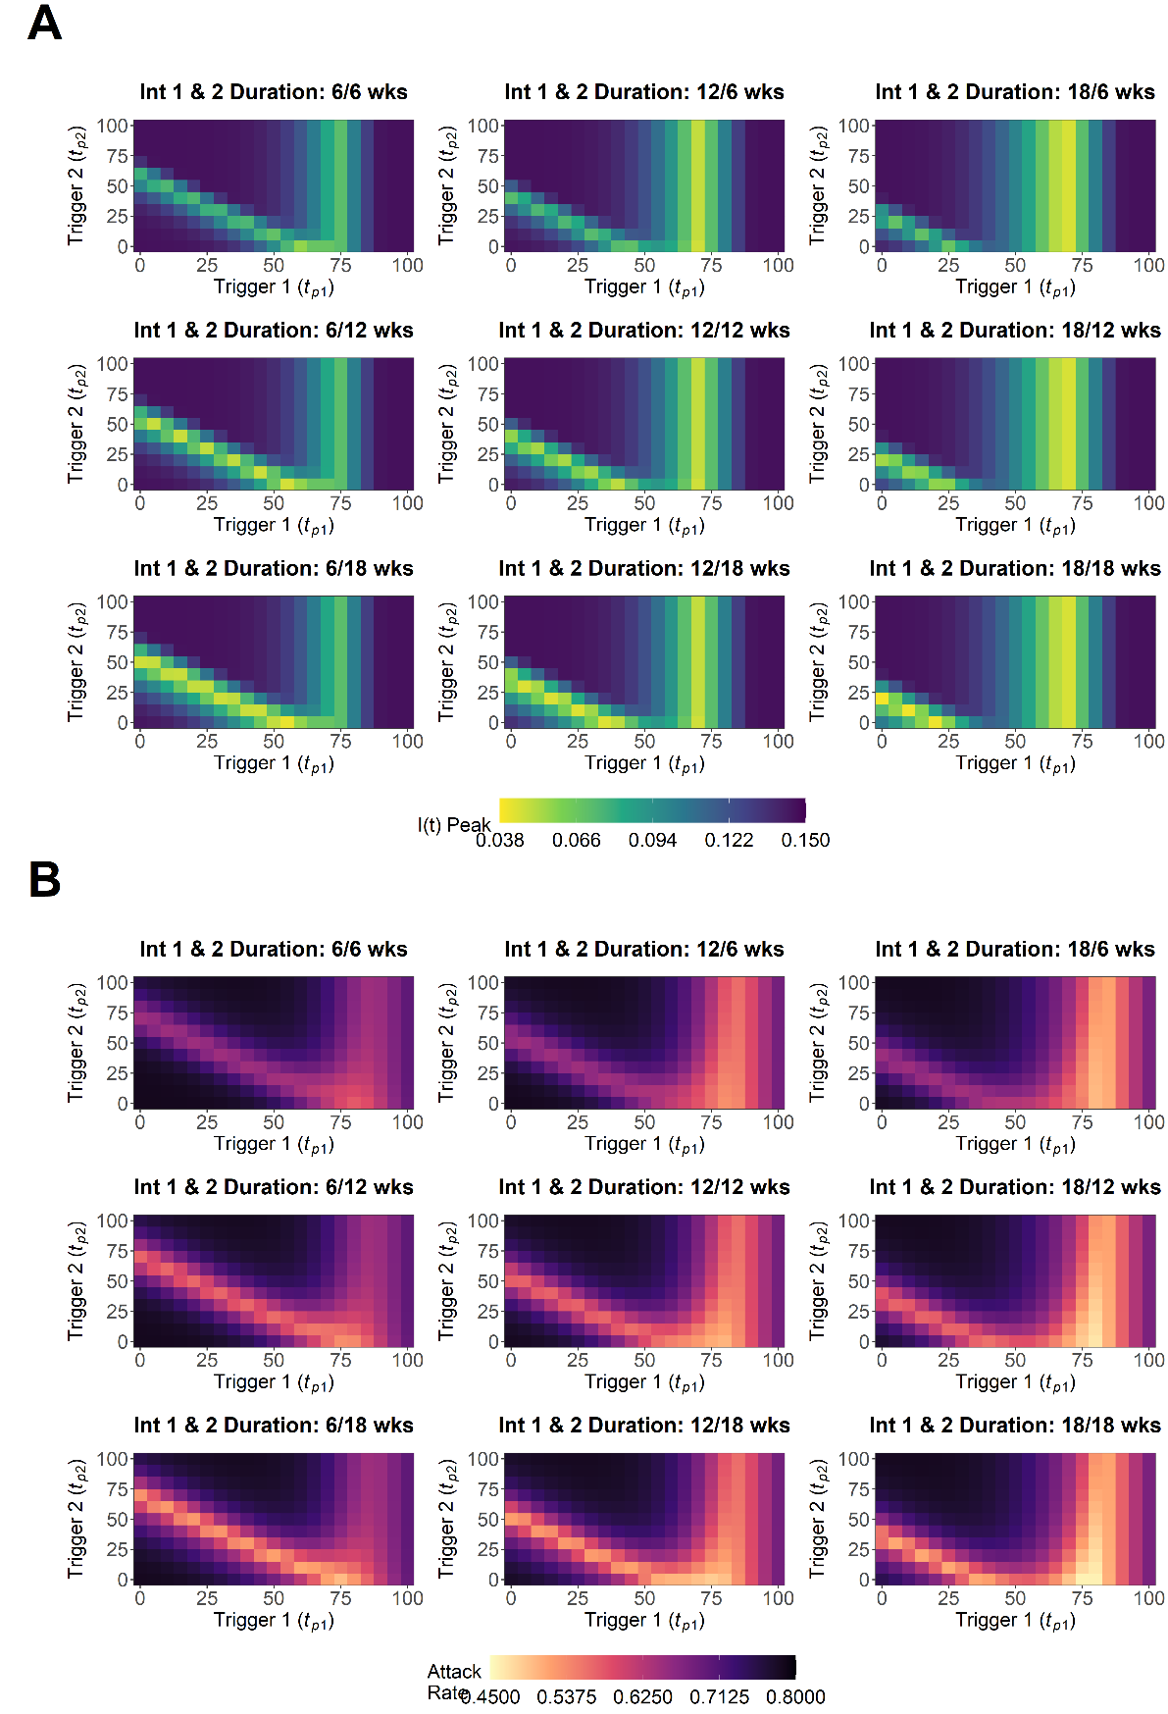

**Figure S7. Scenario 2 sensitivity analysis for A) maximum I(t) peak, *Imax*, and B) attack rate, *Ic(tmax)*, for intervention 1 trigger date, *tp1*, and intervention 2 trigger date, *tp2*, explored for varying combinations of the duration of intervention 1, *dt1*, and intervention 2, *dt2*.** Combinations of *dt1* = *dt2* = 3/6/9 weeks were explored in this sensitivity analysis. Note that explored *dt1*/*dt2* values were doubled relative to scenario 1 (Figure S5), this was to explore the parameter range for *dt1*/*dt2* in the baseline analysis (Figure 4) where scenario 2, 3, 4 and 5 were doubled relative to scenario 1.

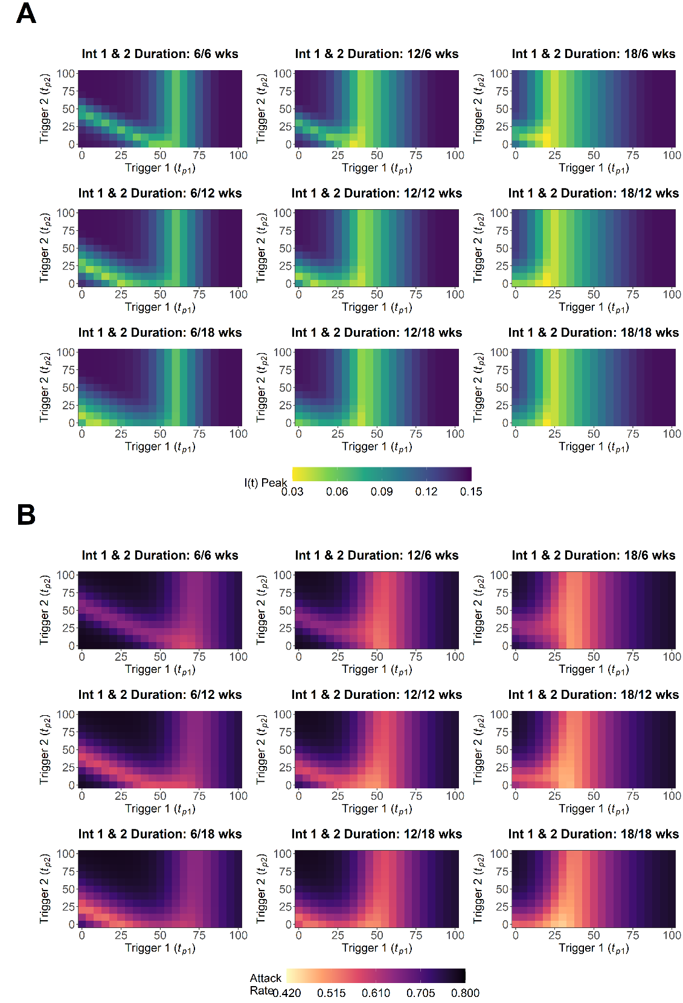

**Figure S8. Scenario 3 sensitivity analysis for A) maximum I(t) peak, *Imax*, and B) attack rate, *Ic(tmax)*, for intervention 1 trigger date, *tp1*, and intervention 2 trigger date, *tp2*, explored for varying combinations of the duration of intervention 1, *dt1*, and intervention 2, *dt2*.** Combinations of *dt1* = *dt2* = 6/12/18 weeks were explored in this sensitivity analysis. Note that explored *dt1*/*dt2* values were doubled relative to scenario 1 (Figure S5), this was to explore the parameter range for *dt1*/*dt2* in the baseline analysis (Figure 4) where scenario 2, 3, 4 and 5 were doubled relative to scenario 1.

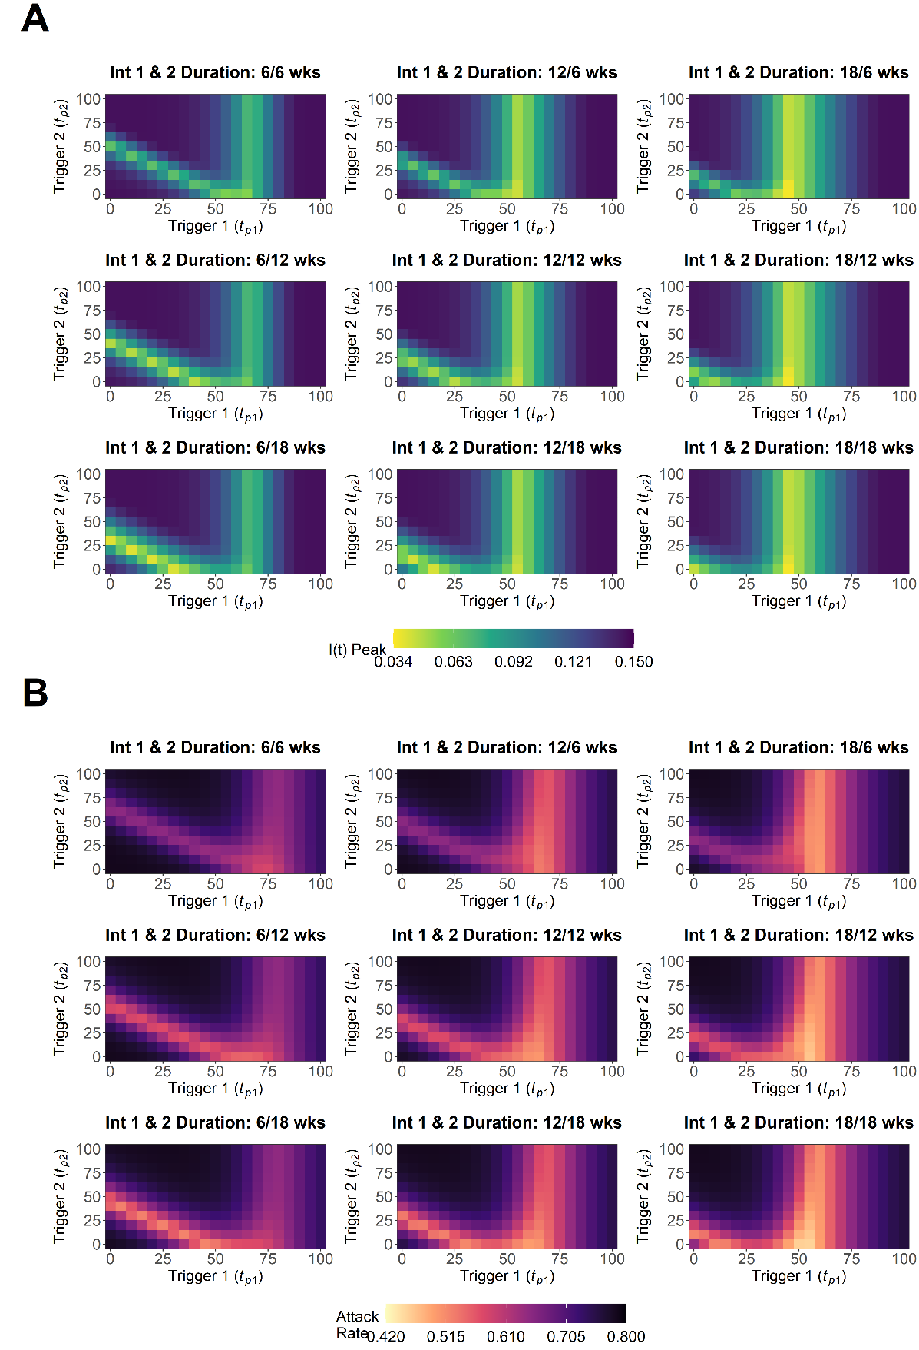

**Figure S9. Scenario 4 sensitivity analysis for A) maximum I(t) peak, *Imax*, and B) attack rate, *Ic(tmax)*, for intervention 1 trigger date, *tp1*, and intervention 2 trigger date, *tp2*, explored for varying combinations of the duration of intervention 1, *dt1*, and intervention 2, *dt2*.** Combinations of *dt1* = *dt2* = 6/12/18 weeks were explored in this sensitivity analysis. Note that explored *dt1*/*dt2* values were doubled relative to scenario 1 (Figure S5), this was to explore the parameter range for *dt1*/*dt2* in the baseline analysis (Figure 4) where scenario 2, 3, 4 and 5 were doubled relative to scenario 1.

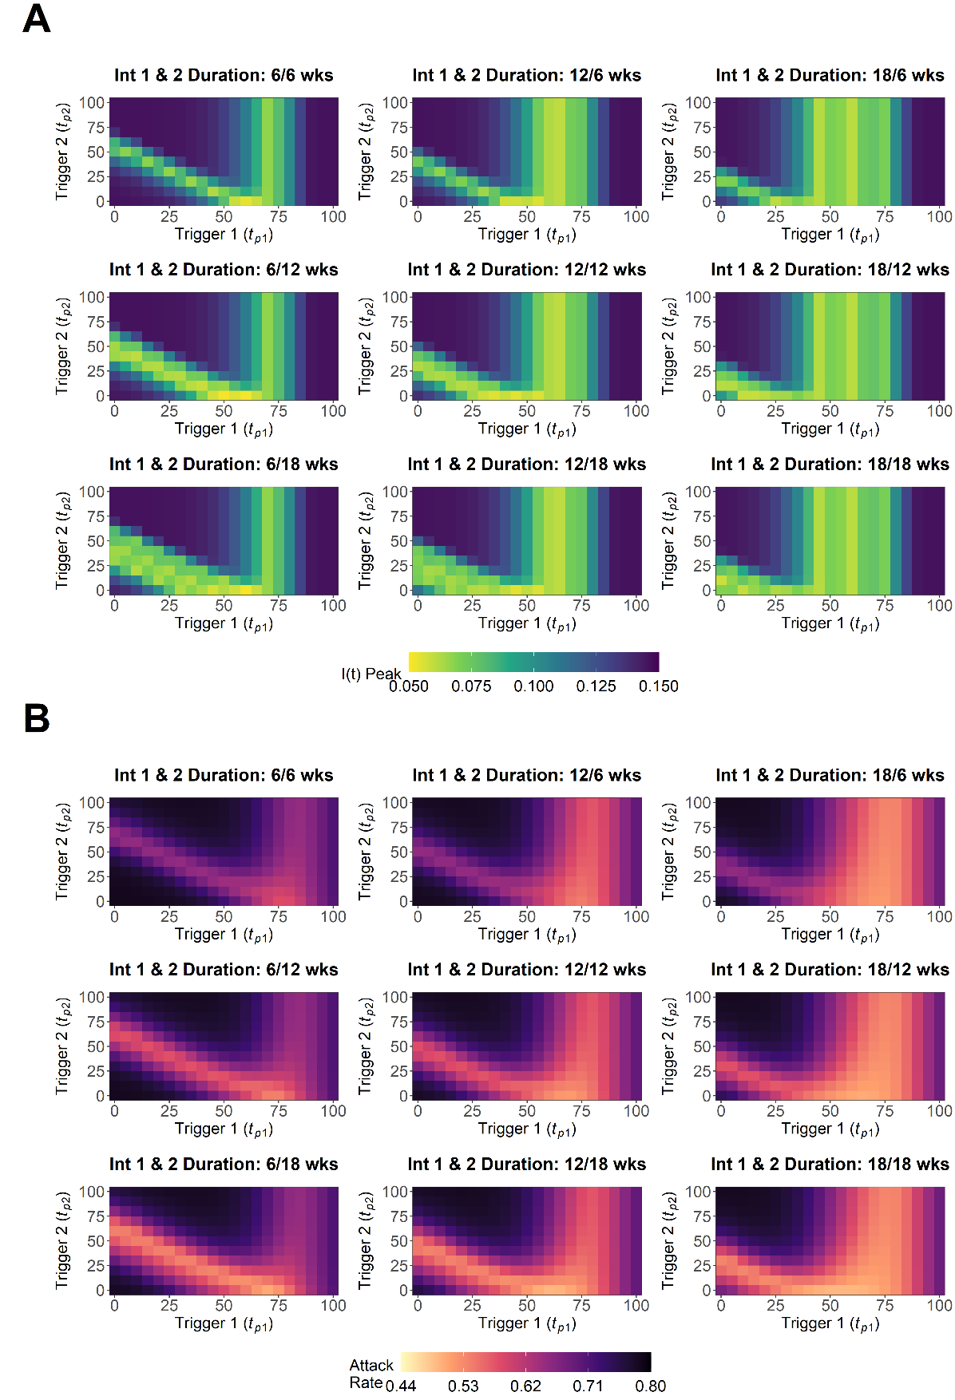

**Figure S10. Scenario 5 sensitivity analysis for A) maximum I(t) peak, *Imax*, and B) attack rate, *Ic(tmax)*, for intervention 1 trigger date, *tp1*, and intervention 2 trigger date, *tp2*, explored for varying combinations of the duration of intervention 1, *dt1*, and intervention 2, *dt2*.** Combinations of *dt1* = *dt2* = 6/12/18 weeks were explored in this sensitivity analysis. Note that explored *dt1*/*dt2* values were doubled relative to scenario 1 (Figure S5), this was to explore the parameter range for *dt1*/*dt2* in the baseline analysis (Figure 4) where scenario 2, 3, 4 and 5 were doubled relative to scenario 1.

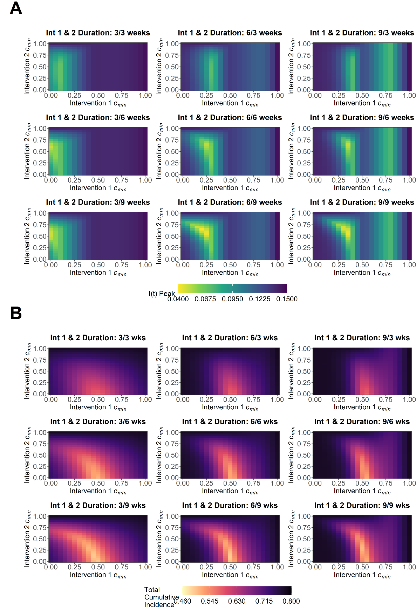

**Figure S11. Scenario 1 sensitivity analysis for A) maximum I(t) peak, *Imax*, and B) the attack rate, *Ic(tmax)*, for the minimum value of scaling factor *c(t)* for intervention 1, *cmin1*, and intervention 2, *cmin2*, explored for varying combinations of the duration of intervention 1, *dt1*, and intervention 2, *dt2*.** Combinations of *dt1* = *dt2* = 3/6/9 weeks were explored in this sensitivity analysis.

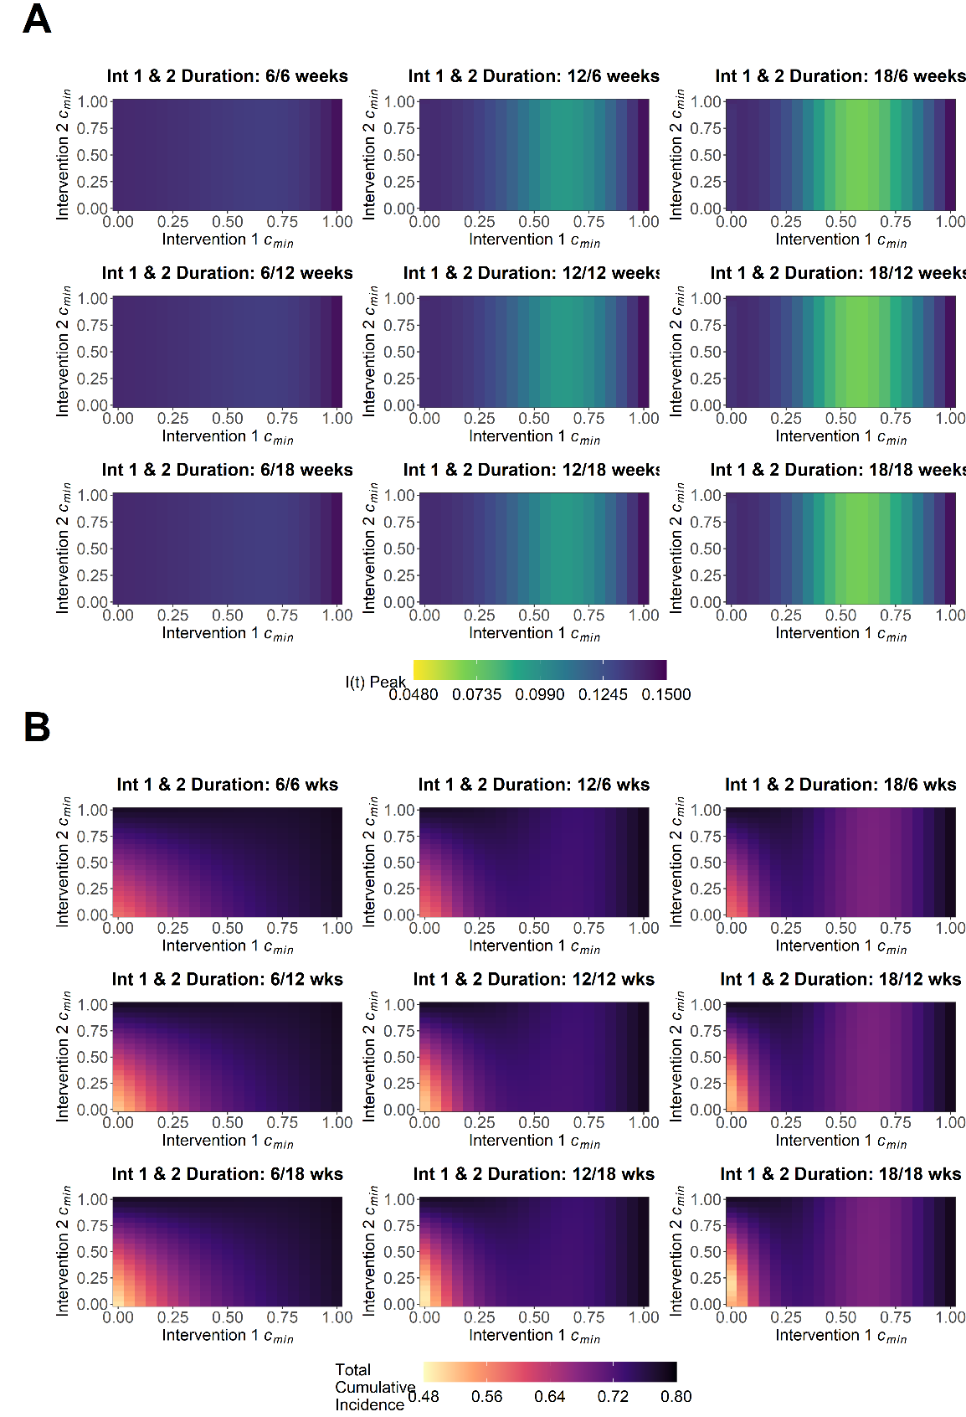

**Figure S12. Scenario 2 sensitivity analysis for A) maximum I(t) peak, *Imax*, and B) the attack rate, *Ic(tmax)*, for the minimum value of scaling factor *c(t)* for intervention 1, *cmin1*, and intervention 2, *cmin2*, explored for varying combinations of the duration of intervention 1, *dt1*, and intervention 2, *dt2*.** Combinations of *dt1* = *dt2* = 6/12/18 weeks were explored in this sensitivity analysis. Note that explored *dt1*/*dt2* values were doubled relative to scenario 1 (Figure S15), this was to explore the parameter range for *dt1*/*dt2* in the baseline analysis (Figure 4) where scenario 2, 3, 4 and 5 were doubled relative to scenario 1.

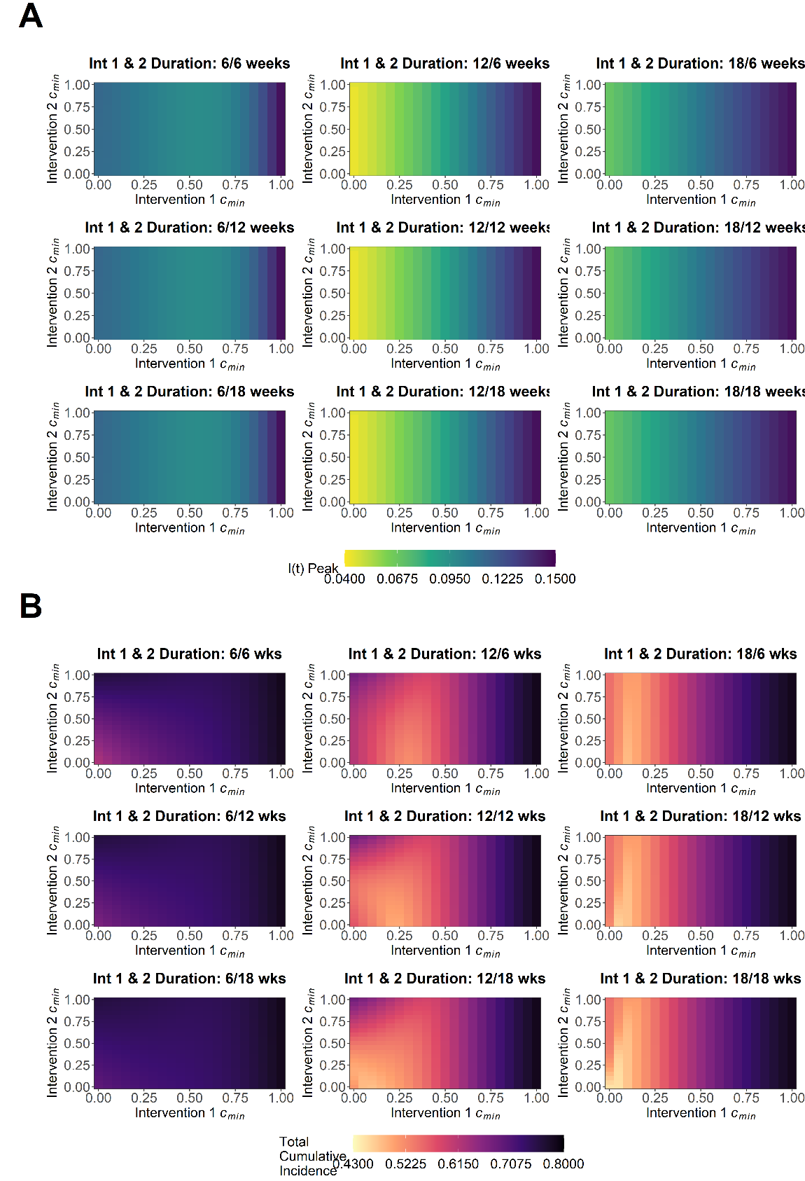

**Figure S13. Scenario 3 sensitivity analysis for A) maximum I(t) peak, *Imax*, and B) the attack rate, *Ic(tmax)*, for the minimum value of scaling factor *c(t)* for intervention 1, *cmin1*, and intervention 2, *cmin2*, explored for varying combinations of the duration of intervention 1, *dt1*, and intervention 2, *dt2*.** Combinations of *dt1* = *dt2* = 6/12/18 weeks were explored in this sensitivity analysis. Note that explored *dt1*/*dt2* values were doubled relative to scenario 1 (Figure S15), this was to explore the parameter range for *dt1*/*dt2* in the baseline analysis (Figure 4) where scenario 2, 3, 4 and 5 were doubled relative to scenario 1.

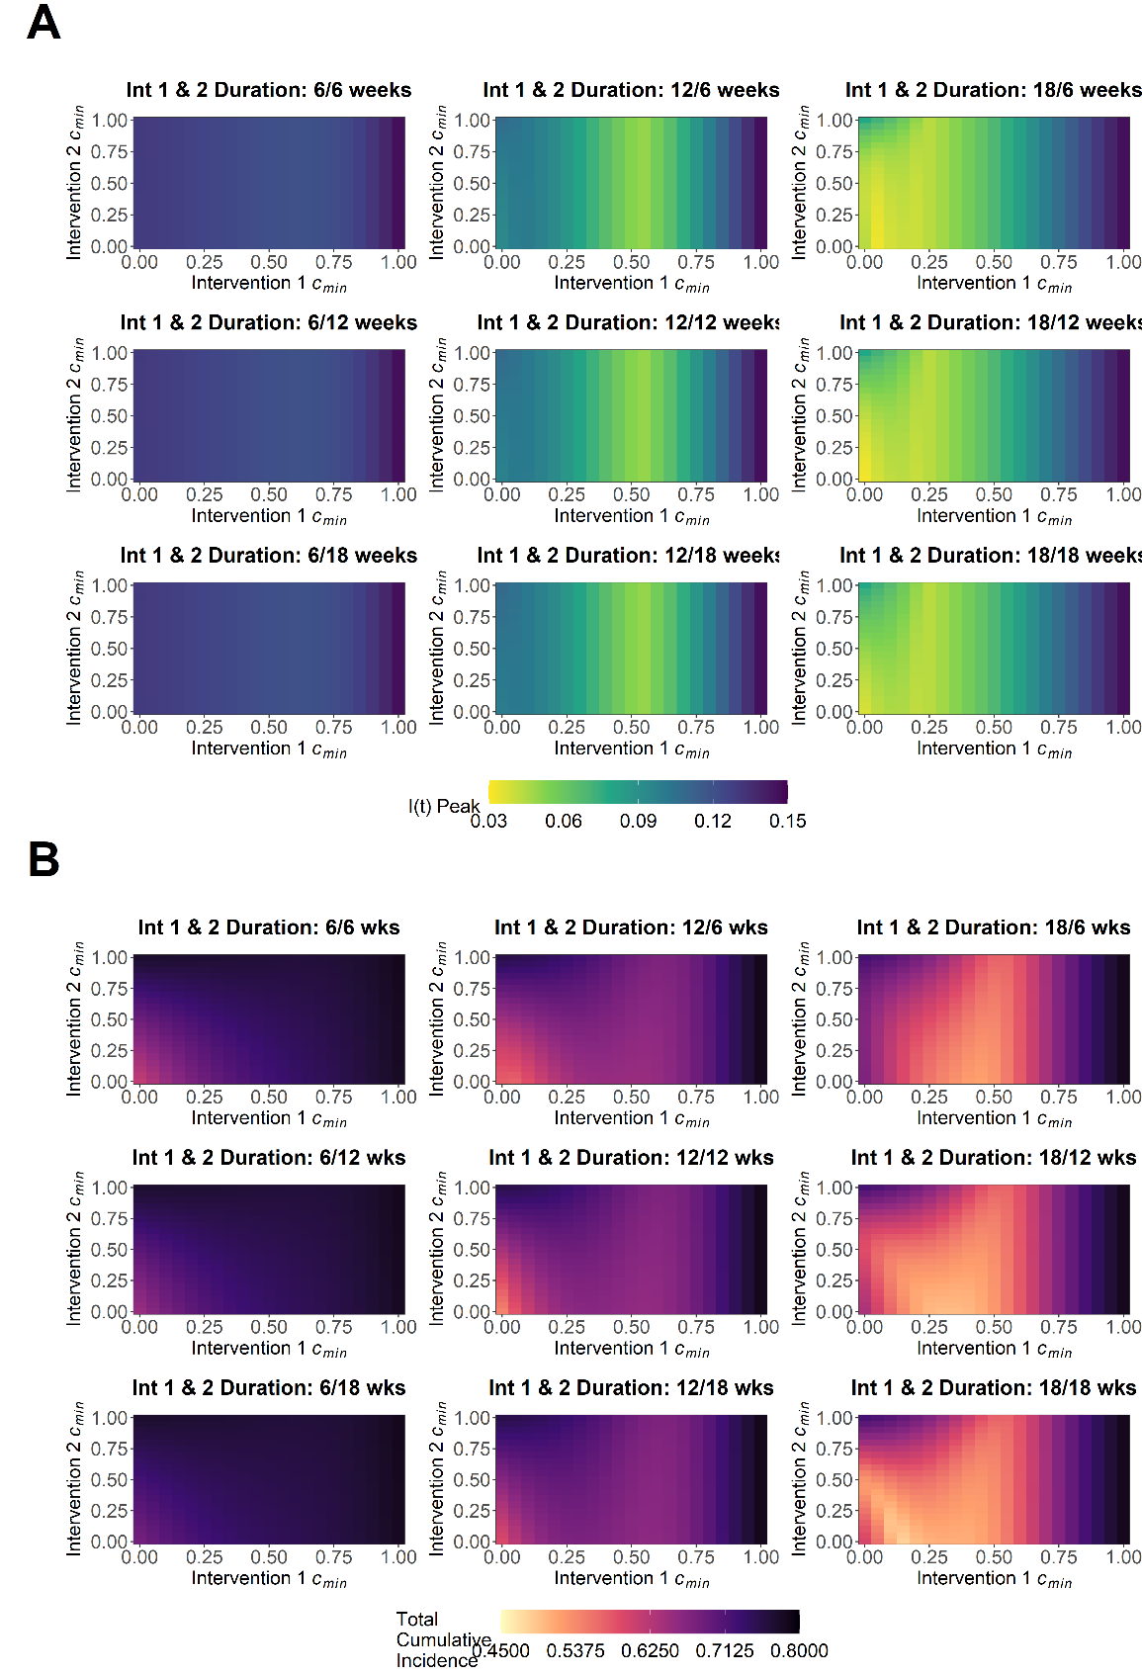

**Figure S14. Scenario 4 sensitivity analysis for A) maximum I(t) peak, *Imax*, and B) the attack rate, *Ic(tmax)*, for the minimum value of scaling factor *c(t)* for intervention 1, *cmin1*, and intervention 2, *cmin2*, explored for varying combinations of the duration of intervention 1, *dt1*, and intervention 2, *dt2*.** Combinations of *dt1* = *dt2* = 6/12/18 weeks were explored in this sensitivity analysis. Note that explored *dt1*/*dt2* values were doubled relative to scenario 1 (Figure S15), this was to explore the parameter range for *dt1*/*dt2* in the baseline analysis (Figure 4) where scenario 2, 3, 4 and 5 were doubled relative to scenario 1.

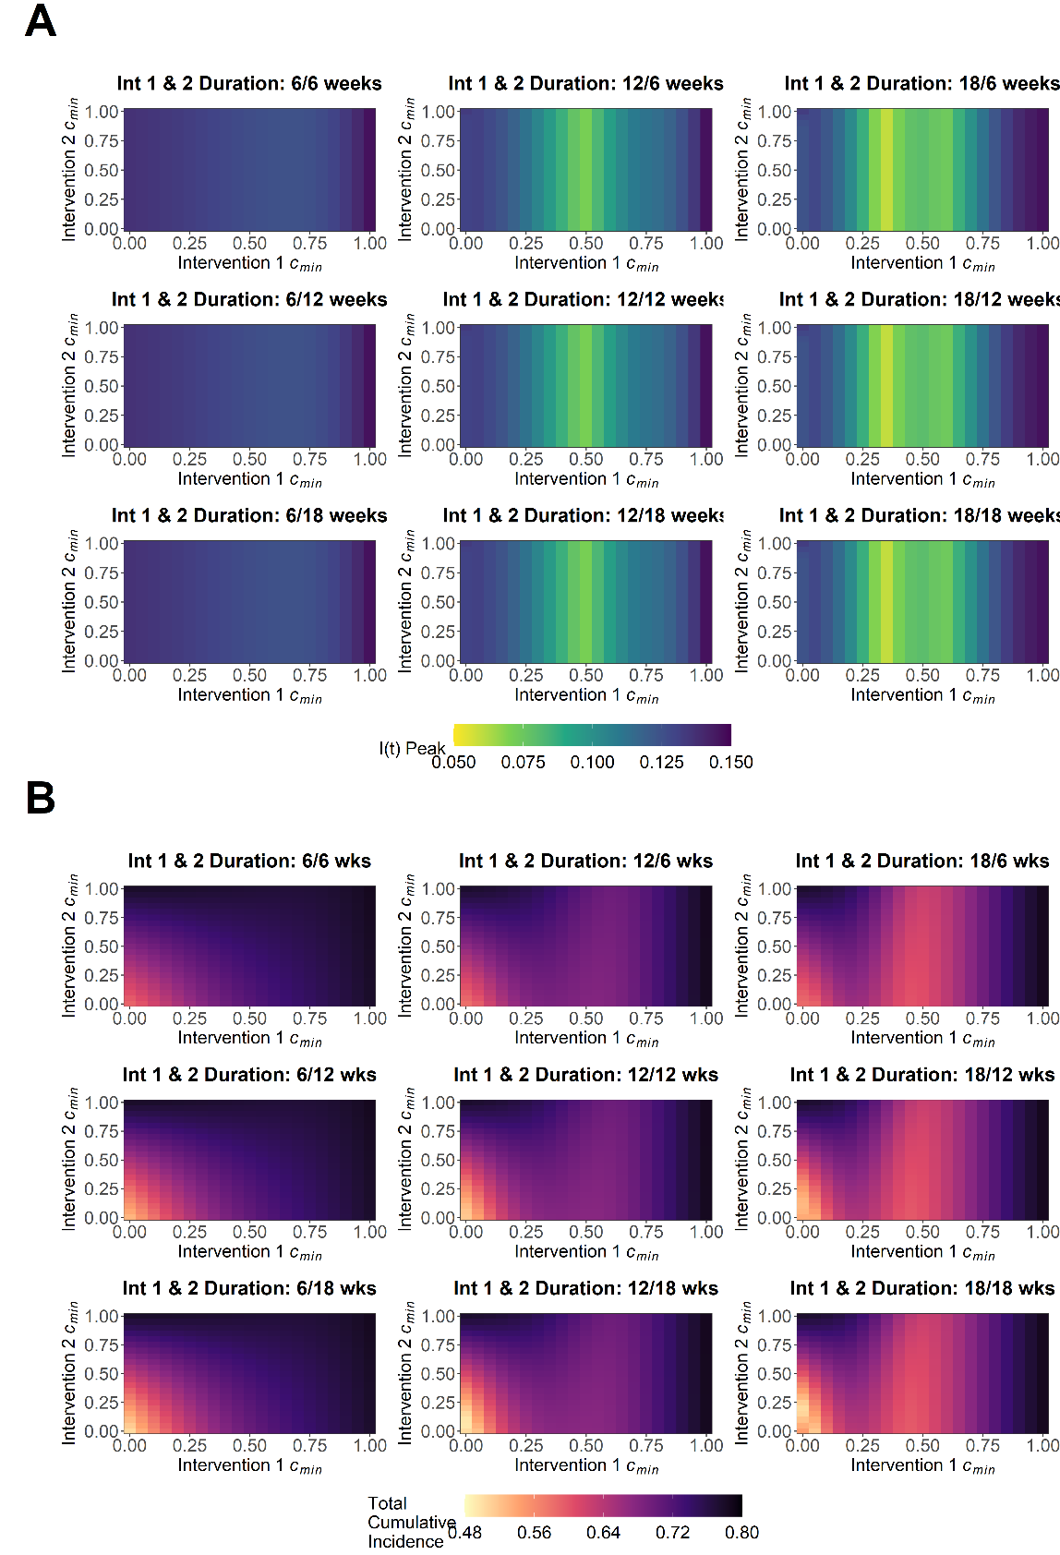

**Figure S15. Scenario 5 sensitivity analysis for A) maximum I(t) peak, *Imax*, and B) the attack rate, *Ic(tmax)*, for the minimum value of scaling factor *c(t)* for intervention 1, *cmin1*, and intervention 2, *cmin2*, explored for varying combinations of the duration of intervention 1, *dt1*, and intervention 2, *dt2*.** Combinations of *dt1* = *dt2* = 6/12/18 weeks were explored in this sensitivity analysis. Note that explored *dt1*/*dt2* values were doubled relative to scenario 1 (Figure S15), this was to explore the parameter range for *dt1*/*dt2* in the baseline analysis (Figure 4) where scenario 2, 3, 4 and 5 were doubled relative to scenario 1.

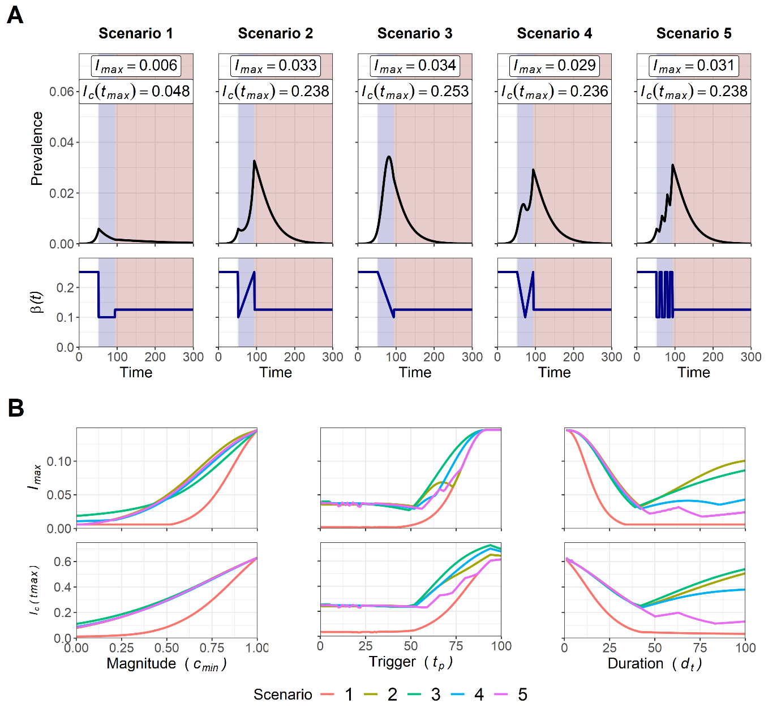

**Figure S16. A) Trajectory plots and changes in *β(t)* for the multi-intervention scenario, with intervention 1 allowed to change and with intervention 2 indefinitely set at a scenario 1 *c(t)* profile with *cmin2* = 0.5. B) Sensitivity analysis for intervention trigger day (*tp*), magnitude of lockdown measures (*cmin*) and intervention duration (*dt*) to minimise maximum *I(t)* peak, *Imax*, and the attack rate, *Ic(tmax)*.** The purpose of this analysis was to represent the optimisation of an initial intervention, with the introduction of more sustainable reductions in transmission (test, track and trace capacity) modelled through indefinite reductions to transmission in intervention 2. Note that for A) blue shading indicates the period of intervention 1 and red shading indicates period of intervention 2. *Imax* and *Ic(tmax)* values are annotated for each scenario. As *tp2* was set at *t* = 100, it was not possible to compensate for differing intervention magnitudes over the intervention duration for scenario 2, 3, 4 5, with all scenarios set at *dt1* = 42 days (6 weeks). Therefore the scenario 1 trajectory plot and sensitivity analysis was not comparable to all other scenarios.

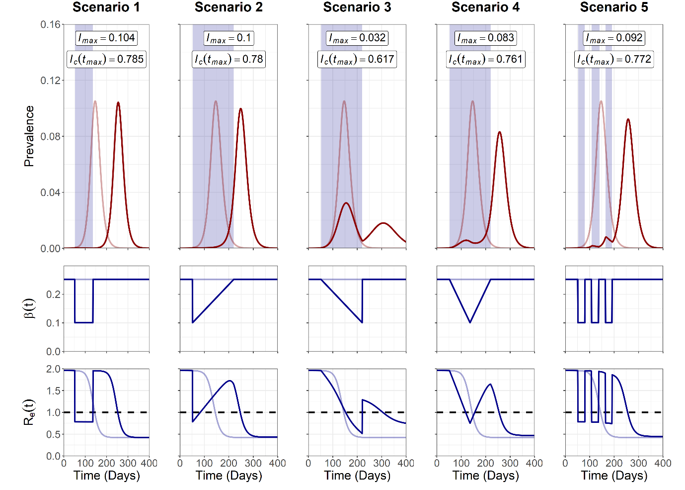

**Figure S17. Trajectory plots, changes in *β(t)* and *Re(t)* for the single-intervention SEIR model for all five scenarios.** Note that parameter *tp* = 90, corresponding to *Ic(90)* = 0.0206. The transition rate from exposed-to-infected, equivalent to the reciprocal of the average duration spent in the COVID-19 incubation period, was set at *σ* = 1/3.*Imax* and *Ic(tmax)* values are annotated for each scenario.

**Appendix References**

1. Di Lauro F, Kiss IZ, Miller J. The timing of one-shot interventions for epidemic control. *medRxiv*. [Preprint]. 2020. Available from: https://doi.org/10.1101/2020.03.02.20030007.

2. Morris DH, Rossine FW, Plotkin JB, Levin SA. Optimal, near-optimal, and robust epidemic control. *arXiv.* [Preprint]. 2020. Available from: <https://arxiv.org/abs/2004.02209>.

3. Gevertz J, Greene J, Tapia CHS, Sontag ED. A novel COVID-19 epidemiological model with explicit susceptible and asymptomatic isolation compartments reveals unexpected consequences of timing social distancing. *medRxiv*. [Preprint]. 2020. Available from: https://doi.org/10.1101/2020.05.11.20098335.

4. Ferguson N, Laydon D, Nedjati Gilani G, Imai N, Ainslie K, Baguelin M, et al. Report 9: Impact of non-pharmaceutical interventions (NPIs) to reduce COVID19 mortality and healthcare demand. [Report]. Imperial College London. 2020. Available from: <https://www.imperial.ac.uk/mrc-global-infectious-disease-analysis/covid-19/report-9-impact-of-npis-on-covid-19/>.

5. Rawson T, Brewer T, Veltcheva D, Huntingford C, Bonsall MB. How and when to end the COVID-19 lockdown: an optimization approach. *Frontiers in Public Health*. 2020. 8:262.

6. Dickens BL, Koo JR, Lim JT, Park M, Quaye S, Sun H, et al. Modelling lockdown and exit strategies for COVID-19 in Singapore. *The Lancet Regional Health-Western Pacific*. [Internet]. 2020. e100004. Available from: <https://doi.org/10.1016/j.lanwpc.2020.100004>.

7. Bin M, Cheung P, Crisostomi E, Ferraro P, Lhachemi H, Murray-Smith R, et al. On fast multi-shot covid-19 interventions for post lock-down mitigation. *arXiv*. [Preprint]. 2020. Available from: https://arxiv.org/abs/2003.09930v5.

8. Sadeghi M, Greene J, Sontag E. Universal features of epidemic models under social distancing guidelines. *bioRxiv*. [Preprint]. 2020. Available from: https://doi.org/10.1101/2020.06.21.163931.

9. Davies NG, Kucharski AJ, Eggo RM, Gimma A, Edmunds WJ, Centre for the Mathematical Modelling of Infectious Diseases C-wg. Effects of non-pharmaceutical interventions on COVID-19 cases, deaths, and demand for hospital services in the UK: a modelling study. *Lancet Public Health*. 2020. 5(7):e375-e85.

10. Pellis L, Scarabel F, Stage HB, Overton CE, Chappell LH, Lythgoe KA, et al. Challenges in control of Covid-19: short doubling time and long delay to effect of interventions. *arXiv.* [Preprint]. 2020. Available from: https://doi.org/10.1101/2020.04.12.20059972.

11. Zhou L, Liu JM, Dong XP, McGoogan JM, Wu ZY. COVID-19 seeding time and doubling time model: an early epidemic risk assessment tool. *Infect Dis Poverty*. 2020. 9(1):76.

12. Pan A, Liu L, Wang C, Guo H, Hao X, Wang Q, et al. Association of Public Health Interventions With the Epidemiology of the COVID-19 Outbreak in Wuhan, China. *JAMA*. 2020. 323(19):1915-1923.

13. Petersen E, Koopmans M, Go U, Hamer DH, Petrosillo N, Castelli F, et al. Comparing SARS-CoV-2 with SARS-CoV and influenza pandemics. *Lancet Infect Dis*. [Internet]. 2020. S1473-3099(20)30484-9. Available from: https://doi.org/10.1016/S1473-3099(20)30484-9.

14. Flaxman S, Mishra S, Gandy A, Unwin HJT, Mellan TA, Coupland H, et al. Estimating the effects of non-pharmaceutical interventions on COVID-19 in Europe. *Nature*. 2020.**584**: 257–261.

15. Anderson RM, May RM. *Infectious diseases of humans: dynamics and control*. Oxford University Press. 1991.

16. Flaxman S, Mishra S, Gandy A, Unwin H, Coupland H, Mellan T, et al. Report 13: Estimating the number of infections and the impact of non-pharmaceutical interventions on COVID-19 in 11 European countries. [Report]. 2020. Available from: <https://www.imperial.ac.uk/mrc-global-infectious-disease-analysis/covid-19/report-13-europe-npi-impact/>.

17. Soetaert KE, Petzoldt T, Setzer RW. Solving differential equations in R: package deSolve. *Journal of statistical software*. 2010. 33(9).

18. Wickham H. ggplot2: elegant graphics for data analysis. *Journal of Statistical Software*. 2017. 77(2).

19. Wickham H. Reshaping data with the reshape package. *Journal of Statistical Software*. 2007. 21(12):1-20.